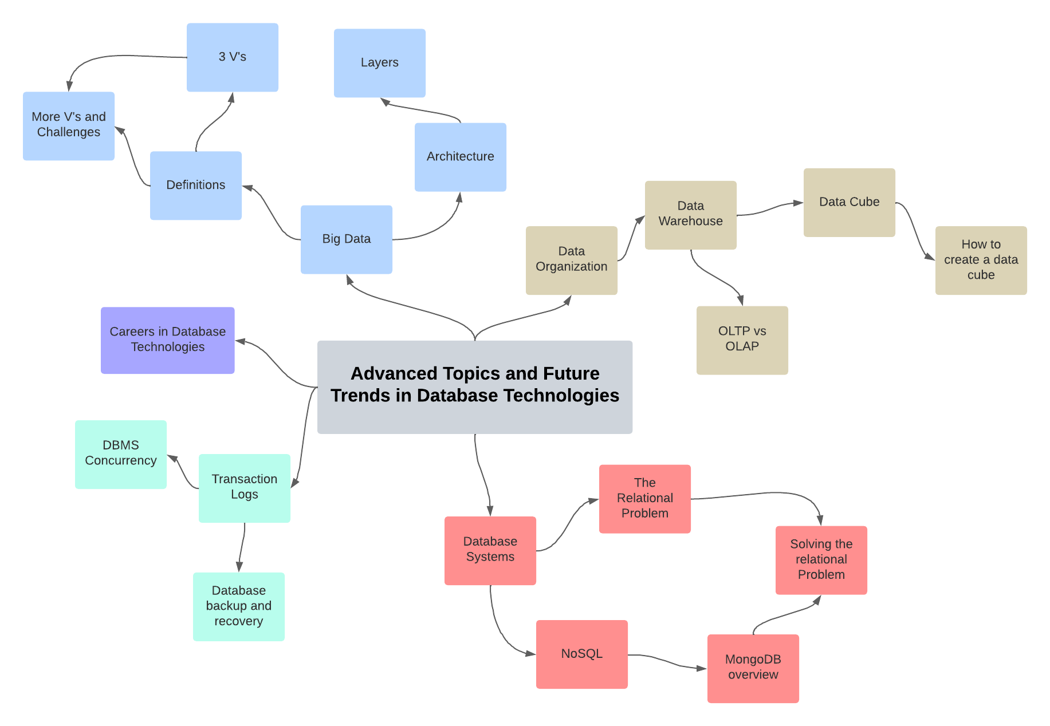

**Concept Map Explanation**

This concept map centers around the main topic of "Database and Big Data Concepts," branching out into detailed subtopics that cover everything from transaction logs and database technologies to big data architecture and NoSQL systems. It visually organizes the concepts to show how they relate to each other, with branches for "Transaction Logs," "Careers in Database Technologies," "Data Organization," and more. Each of these branches further divides into more specific aspects of the field, like "Data Warehouse" under "Data Organization," which then leads to discussions on "OLTP vs OLAP" and "Data Cube," among others. The connections between these topics reflect the progression from foundational knowledge (like how databases manage transactions and maintain data integrity) to more specialized topics (like big data analytics and the use of NoSQL databases to handle non-relational data). My concept map outlines a journey from understanding the core functionalities of databases to exploring the cutting-edge techniques used in big data and analytics, highlighting practical, professional, and theoretical aspects of the field.

1. Transaction Logs: This is essential for ensuring data integrity and is critical for recovery operations. Transaction logs record all transactions that have been made, which is vital for both troubleshooting and restoring databases to a point in time.

- Database Backup and Recovery: These are strategies and processes involved in protecting data against loss and restoring data to an operational state after any loss.

- DBMS Concurrency: This refers to the ability of the database management system to manage simultaneous operations without conflicts. It's connected to transaction logs because concurrency control mechanisms often rely on these logs to maintain data consistency.

2. Careers in Database Technologies:

3. Data Organization: This topic recognizes that data can be structured in various ways depending on its use, such as in databases, data warehouses, or other forms of data repositories.

- Data Warehouse: This is a centralized repository for storing large volumes of data that are typically used for analysis rather than transaction processing.

- OLTP vs OLAP: This distinction between Online Transaction Processing and Online Analytical Processing reflects different approaches to data processing, with one focusing on efficient transactional tasks, the other on complex queries for data analysis.

- Data Cube: A data cube allows data to be modeled and viewed in multiple dimensions and is integral to OLAP operations. It's a structural form of a data warehouse specifically optimized for data analysis.

- How to Create a Data Cube

4. Big Data: Here, the focus is on large data sets that are complex, fast-changing, or massive beyond the ability of traditional databases to handle.

- 3 Vs Definitions: The three Vs (Volume, Velocity, and Variety) are the characteristics that define big data.

- More Vs and Challenges: As the field evolves, more Vs like Veracity, Value , Variability, Visualization, Validity, Vulnerability, and Volatility are added to the definition of big data, bringing new challenges.

- Big Data Architecture and Its Layers: This looks at the architectural approach to managing big data, which is often layered to separate concerns like storage, processing, and analysis.

5. Database Systems:

- The Relational Problem: This refers to challenges that arise from the relational database model, which might not cope well with the requirements of big data like scalability and flexibility.

- NoSQL Systems: These are non-relational databases designed to overcome some of the limitations of relational databases, particularly when dealing with large volumes of unstructured data.

- MongoDB Overview: MongoDB is an example of a NoSQL database that offers a document-oriented approach, which is especially useful in big data applications.

- Solving the Relational Problem: The Relational Problem stems from the incapacity of traditional Relational Database Systems to effectively manage the escalating volume, velocity, and variety of Big Data.

**Data Warehouse**

A data warehouse is a centralized repository that stores large amounts of historical data from various sources within an organization. It's designed to facilitate and support business intelligence activities, especially analytics, data mining, and reporting. Unlike a traditional database, which focuses on processing transactions efficiently, a data warehouse is optimized for querying and analyzing large datasets.

Benefits of a Data Warehouse

1. Improved Decision Making: By consolidating data from multiple sources, data warehouses provide comprehensive insights that help businesses make informed decisions.

2. Enhanced Data Quality and Consistency: Data warehousing involves data cleaning, integration, and consolidation, which improves data quality and ensures consistency across the organization.

3. Historical Intelligence: Data warehouses store historical data, enabling businesses to analyze trends over time, forecast future occurrences, and perform comparative studies.

4. Efficiency: Having a centralized data repository significantly reduces the effort and time required for data retrieval and analysis.

5. Scalability: are designed to scale with the growth of an organization, handling increasing volumes of data efficiently.

Architecture and Layers

The architecture of a data warehouse can be quite complex, but it's generally structured around the following key layers:

1. Data Source Layer: This is where the data originates. It can include various sources such as operational databases, flat files, web services, and external data sources.

2. Data Staging Area: Data from different sources is collected here for cleaning, transformation, and integration. This is a critical step to ensure data quality and consistency.

3. Data Storage Layer: After processing, data is loaded into the data warehouse. This layer is typically organized using schemas such as star schema or snowflake schema to optimize data retrieval.

4. Data Presentation Layer: This is where data is organized, summarized, and made available for end-users through various tools and applications for querying, reporting, and analysis.

5. Metadata, Management, and Data Access Tools: These components support the data warehouse by providing information about data (metadata), managing data storage and retrieval, and facilitating user access.

The 3 Vs of Data Warehousing

The concept of the 3 V's is often associated with big data but is equally relevant to data warehousing, emphasizing the challenges and considerations in managing and analyzing data.

1. Volume: Refers to the amount of data. Data warehouses manage large volumes of historical data, making it a challenge to store and process efficiently.

2. Velocity: The speed at which data is generated, collected, and processed. Data warehouses need to handle the rapid flow of data from various sources.

3. Variety: The different types of data that need to be processed and integrated. Data warehouses must accommodate this diversity to provide a holistic view of the business.

In summary, a data warehouse is a powerful tool for consolidating diverse data sets into a single source of truth, supporting complex analytical queries and strategic decision-making across an organization. Its architecture is designed to ensure data quality, facilitate efficient data analysis, and scale with the needs of the business, while managing the challenges of volume, velocity, and variety.